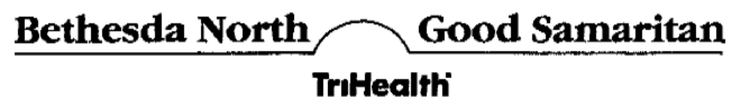

AUTHORIZATION FOR USE OR DISCLOSURE
OF PROTECTED HEALTH INFORMATION

I, | Karen Marcetti |  | [Print Name of Patient] hereby authorize TriHealth, Inc.,
Bethesda Hospital, Inc. and The Good Samaritan Hospital of Cincinnati, Ohio (referred to as "Health Care Provider") to use and/or disclose my individually identifiable health information as described below:

I authorize the following person($) or organization to receive the information:
Axiom Requisition Copy Service as agent of MHA Insurance Company
Street Address:
447 North Canal Road
City, State and Zip Code:
Lansing, MI 48917
The following individually identifiable health information may be used and/or disclosed:
Billing records including itemized statements from the hospital(s) checked below:

☑ Bethesda Hospital ☑ Good Samaritan Hospital
Dates of Treatment to be released: |  | 12/22/1965 to Present
I authorize the release of any information contained in the above records concerning treatment of drug or alcohol abuse, drug-related conditions, alcoholism, and/or psychiatric/psychological condition and/or psychiatric/mental health treatment and/or HIV related conditions.

Reason or purpose For the use andlor disclosure of the information:
Legal matter Marcetti v. Barkel, M.D.
Your Refusal to Sign this Authorization: The health care provider may not condition
treatment on whether or not you sign this Authorization. If you refuse to sign this Authorization
the health care provider will not withhold treatment from you.

Re-disclosure: I understand that the information used and/or disclosed pursuant to this Authorization may be re-disclosed by the recipient of the information and may no longer be protected by Federal law. However, if the information disclosed pursuant to this Authorization includes alcohol or drug treatment records, the person(s) receiving such disclosure is hereby notified that this information has been disclosed from records protected by Federal confidentiality”rules (42 CFR part 2). The Federal rules prohibit such person(s) from making any further disclosure of this Information unless further disclosure is expressly permitted by the written”consent of the person to whom it pertains or as otherwise permitted by 42 CFR part 2. A general authorization for the release of medical or other information is NOT sufficient for this purpose. The Federal rules restrict any use of the information to criminally investigate or prosecute”any alcohol or drug abuse patient. If the information disclosed pursuant to this informational
1
Order No. 01-12345-003 (Page 1 of 2)

Authorization includes the identity of an individual on whom an HIV test is performed, HIV test results or AIDS-related treatment information, the person(s) receiving such disclosure is hereby notified that this information has been disclosed from confidential records protected from disclosure by Ohio law. Ohio law prohibits such person(s) from making any further disclosure of”this information without the specific, written, and informed release of the patient to whom it pertains, or as otherwise permitted by Ohio law. A general authorization for the release of medical”or other information is not sufficient for the purpose of the release of HIV test results or diagnoses.

Expiration: This Authorization will expire one (1) year after the date below, or sooner by
choice, in which case this Authorization will expire on _____________________ (insert date on the foregoing line; Note: you may not indicate that there is no expiration, for example the words "does not expire" or "no expiration" or "none" are not acceptable).

Revocation: I understand that I may revoke this Authorization at any time by notifying
TriHealth in writing by sending a letter to the Director, Patient Accounting, TriHealth, Inc., 619 Oak Street, Cincinnati, Ohio 45206. I understand that if I revoke this Authorization, it will not affect any actions that TriHealth took before it received my revocation letter.

SIGNATURE OF PATIENT OR PATIENT’S REPRESENTATIVE |  |  |  |  |  |  | DATE |  | PHONE #
*Patient’s Date of Birth: |  |  | 12/22/1965
*Patient’s Social Security Number: |  |  |  | XXX-XX-5076
 | *The above information is required in order to verify the identity of the patient and locate the patient’s protected health information.
Printed name of patient’s representative, if applicable:
Relationship to patient:
Please note that there will be a charge to reproduce records that are not being sent to a physician or health care facility for further medical care. TriHealtb may use a copy service and it may bill you directly.

2
Order No. 01-12345-003 (Page 2 of 2)

